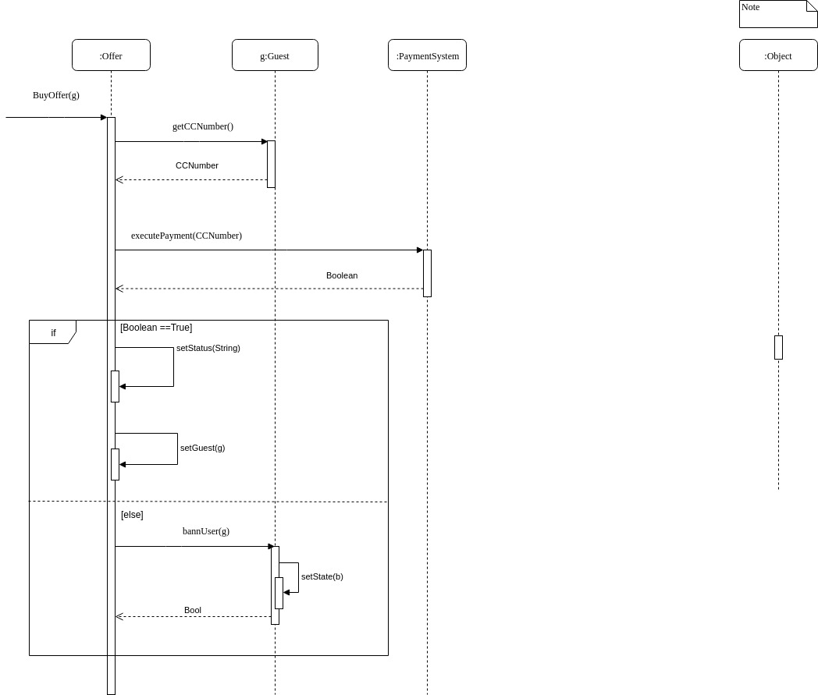This diagram describes the process of buying an offer. First, the application takes the Credit Card number and then the Payment System processes the payment. If the number is wrong, the administrator bans the user, otherwise the offer is set as bought by the guest.

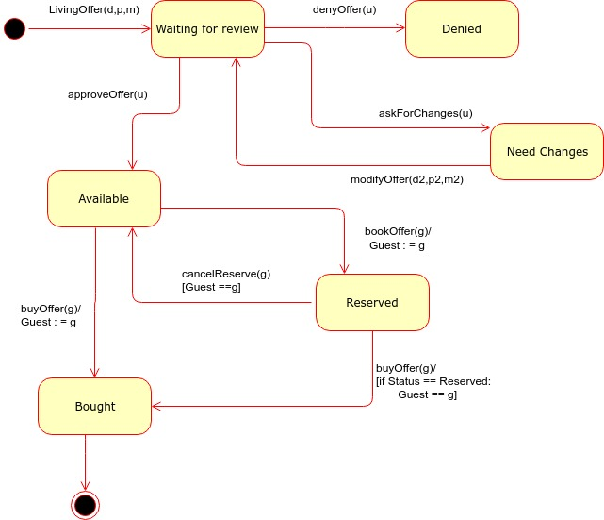

This diagram exposes the different states of an offer. First it has to be revised by the admin, who will deny, accept or ask for changes in it. If it’s accepted, then is available and a guest can reserve it and buy it later or buy it directly.

|  |  |  |  |  |  |
| --- | --- | --- | --- | --- | --- |
| Methods | General User | Guest | Host | Administrator | Payment System |
| login() |  | **X** | **X** | **X** |  |
| logout() |  | **X** | **X** | **X** |  |
| searchType() | **X** | **X** |  |  |  |
| searchCode() | **X** | **X** |  |  |  |
| searchDate() | **X** | **X** |  |  |  |
| searchBought() |  | **X** |  |  |  |
| searchBooked() |  | **X** |  |  |  |
| searchRate() |  | **X** |  |  |  |
| createOffer() |  |  | **X** |  |  |
| createHouse() |  |  | **X** |  |  |
| changeCC() |  |  |  | **X** |  |
| checkCC() |  |  |  | **X** |  |
| commentComment() |  | **X** |  |  |  |
| buyOffer() |  | **X** |  |  |  |
| bookOffer() |  | **X** |  |  |  |
| isReserved() |  | **X** | **X** |  |  |
| isBought() |  | **X** | **X** |  |  |
| commentOffer() |  | **X** |  |  |  |
| cancelReserve() |  | **X** |  |  |  |
| denyOffer() |  |  |  | **X** |  |
| approveOffer() |  |  |  | **X** |  |
| modifyOffer() |  |  | **X** |  |  |
| executePayment() |  |  |  |  | **X** |
| bannUser() |  |  |  | **X** |  |